OSSP
Practical Session 6 - Client–Server Application using Named Pipes (FIFOs)
Create a client-server application using Named Pipes(FIFOs). The client sends messages and the server processes and responds to them. Analyze FIFO behavior when multiple clients communicate simultaneously.
Objective
Create a client-server application using two Named Pipes (FIFOs):
- Client sends a message to the server.
- Server processes the message and sends a response.
- Multiple clients can communicate with the same server.
- Each client has a separate response FIFO.
File 1: prog6_fifo_server.c
#include <stdio.h>
#include <stdlib.h>
#include <string.h>
#include <fcntl.h>
#include <unistd.h>
#include <sys/stat.h>
#include <errno.h>
#define SERVER_FIFO "/tmp/server_fifo"
#define MAX_MSG 256
typedef struct {
pid_t client_pid;
char message[MAX_MSG];
} Request;
typedef struct {
char response[MAX_MSG];
} Response;

int main()
{
int server_fd;
Request request;
char client_fifo[100];
/* Create server FIFO */
if (mkfifo(SERVER_FIFO, 0666) == -1 && errno != EEXIST) {
perror("mkfifo");
exit(EXIT_FAILURE);
}
printf("Server started...\n");
printf("Waiting for clients...\n");
/*
* Open server FIFO for reading.
* O_RDWR prevents read() from receiving EOF when there are temporarily no writers.
*/
server_fd = open(SERVER_FIFO, O_RDWR);
if (server_fd == -1) {
perror("open");
unlink(SERVER_FIFO);
exit(EXIT_FAILURE);
}
while (1) {
ssize_t n = read(server_fd, &request, sizeof(Request));
if (n <= 0) {
continue;
}

printf("\nReceived from Client PID %d: %s\n", request.client_pid, request.message);
/* Create client's FIFO name */
snprintf(client_fifo, sizeof(client_fifo), "/tmp/client_%d_fifo", request.client_pid);
int client_fd = open(client_fifo, O_WRONLY);
if (client_fd == -1) {
perror("open client FIFO");
continue;
}
Response response;
snprintf(response.response, sizeof(response.response), "Server processed: %s",
request.message);
write(client_fd, &response, sizeof(response));
close(client_fd);
printf("Response sent to Client PID %d\n",
request.client_pid);
}
close(server_fd);
unlink(SERVER_FIFO);
return 0;
}

File 2: prog6_fifo_client.c
#include <stdio.h>
#include <stdlib.h>
#include <string.h>
#include <fcntl.h>
#include <unistd.h>
#include <sys/stat.h>

#define SERVER_FIFO "/tmp/server_fifo"
#define MAX_MSG 256
typedef struct {
pid_t client_pid;
char message[MAX_MSG];
} Request;
typedef struct {
char response[MAX_MSG];
} Response;

int main()
{
int server_fd, client_fd;
char client_fifo[100];
char message[MAX_MSG];
Request request;
Response response;
pid_t pid = getpid();
/* Create unique FIFO for this client */
snprintf(client_fifo,
sizeof(client_fifo),
"/tmp/client_%d_fifo",
pid);
if (mkfifo(client_fifo, 0666) == -1) {
perror("mkfifo");
exit(EXIT_FAILURE);
}

printf("Client PID: %d\n", pid);
printf("Enter message: ");
fgets(message, sizeof(message), stdin);
/* Remove newline */
message[strcspn(message, "\n")] = '\0';
request.client_pid = pid;
strcpy(request.message, message);
/* Open server FIFO */
server_fd = open(SERVER_FIFO, O_WRONLY);
if (server_fd == -1) {
perror("Unable to open server FIFO");
unlink(client_fifo);
exit(EXIT_FAILURE);
}

/* Send request */
write(server_fd, &request, sizeof(request));
close(server_fd);
printf("Message sent to server.\n");
/* Open client's FIFO for response */
client_fd = open(client_fifo, O_RDONLY);
if (client_fd == -1) {
perror("Unable to open client FIFO");
unlink(client_fifo);
exit(EXIT_FAILURE);
}

/* Receive response */
read(client_fd, &response, sizeof(response));
printf("Server Response: %s\n", response.response);
close(client_fd);
/* Remove client's FIFO */
unlink(client_fifo);
return 0;
}
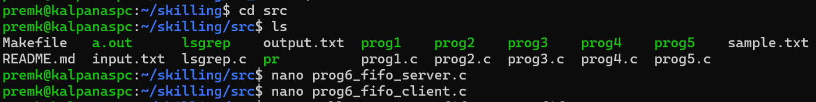
Compilation
Open three WSL/Linux terminals.
Terminal 1 – Compile and run server
gcc -Wall -Wextra -o fifo_server fifo_server.c
./fifo_server
Output:
Server started...
Waiting for clients...
Terminal 2 – Compile and run Client 1
gcc -Wall -Wextra -o fifo_client fifo_client.c
./fifo_client
Example:
Client PID: 2451
Enter message: Hello Server
Message sent to server.
Server Response: Server processed: Hello Server
Terminal 3 – Run Client 2
./fifo_client
Example:
Client PID: 2458
Enter message: How are you?
Message sent to server.
Server Response: Server processed: How are you?
Server output
Received from Client PID 2451: Hello Server
Response sent to Client PID 2451
Received from Client PID 2458: How are you?
Response sent to Client PID 2458
Outputs:
1st terminal – Server
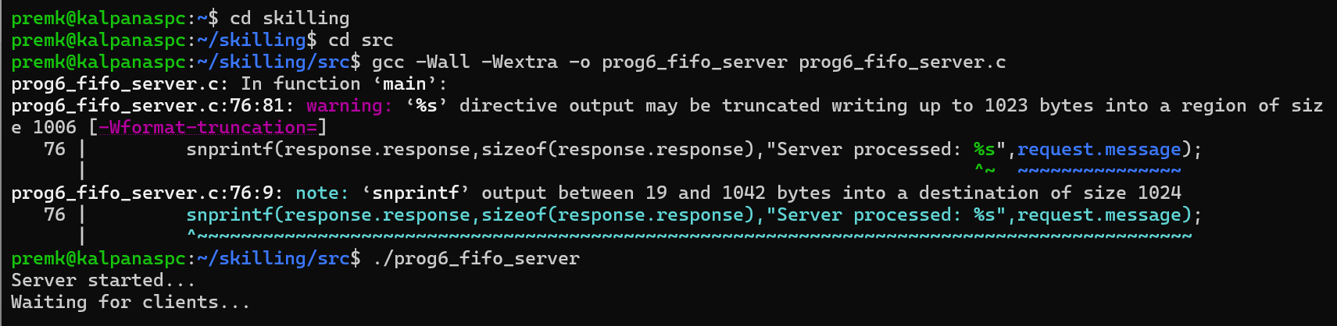
2nd terminal – Client 1
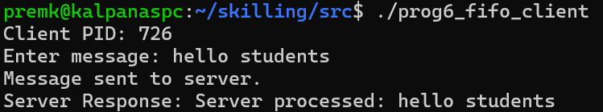
3rd terminal – Client 2
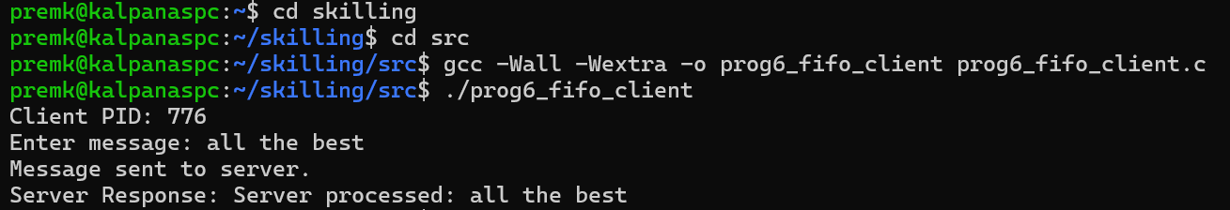
Now go to 1st terminal – Server and view the communication
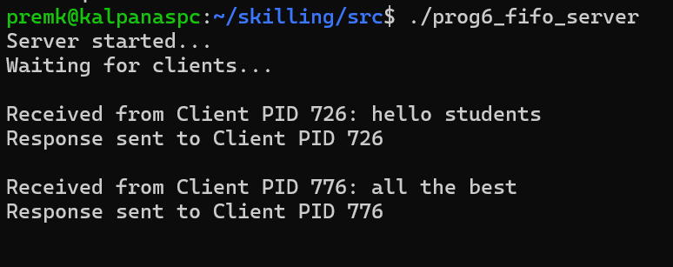

Multiple-client FIFO behavior
When multiple clients send messages simultaneously:
- All clients write requests to the same server FIFO.
- The server reads requests in the order they become available.
- The server processes them sequentially in this program.
- Each client receives its response through its own FIFO.
- Writes smaller than or equal to PIPE_BUF are atomic, which helps prevent individual FIFO writes from being interleaved.
To clean up after stopping the server:
rm -f /tmp/server_fifo /tmp/client_*_fifo

2. POSIX Signal Handling Program
Create a POSIX signal handling program that captures SIGINT, SIGTERM, and SIGUSR1. Demonstrate asynchronous event handling and explain the role of signal handlers.
This program captures:
- SIGINT → normally generated by Ctrl+C
- SIGTERM → termination request
- SIGUSR1 → user-defined signal
It uses sigaction(), which is preferred over the older signal() interface.

File: signal_handler.c
#include <stdio.h>
#include <stdlib.h>
#include <unistd.h>
#include <signal.h>
#include <string.h>
volatile sig_atomic_t sigint_received = 0;
volatile sig_atomic_t sigterm_received = 0;
volatile sig_atomic_t sigusr1_received = 0;

/*
* Signal handler
*/
void signal_handler(int signo)
{
if (signo == SIGINT) {
sigint_received = 1;
}
else if (signo == SIGTERM) {
sigterm_received = 1;
}
else if (signo == SIGUSR1) {
sigusr1_received = 1;
}
}

int main()
{
struct sigaction sa;
memset(&sa, 0, sizeof(sa));
sa.sa_handler = signal_handler;
sigemptyset(&sa.sa_mask);
/*
* Register signal handlers
*/
if (sigaction(SIGINT, &sa, NULL) == -1) {
perror("sigaction SIGINT");
exit(EXIT_FAILURE);
}
if (sigaction(SIGTERM, &sa, NULL) == -1) {
perror("sigaction SIGTERM");
exit(EXIT_FAILURE);
}
if (sigaction(SIGUSR1, &sa, NULL) == -1) {
perror("sigaction SIGUSR1");
exit(EXIT_FAILURE);
}

printf("Signal handling program started.\n");
printf("Process PID = %d\n", getpid());
printf("\nSend signals using:\n");
printf("SIGINT : kill -SIGINT %d\n", getpid());
printf("SIGTERM : kill -SIGTERM %d\n", getpid());
printf("SIGUSR1 : kill -SIGUSR1 %d\n", getpid());

while (1) {
pause();
if (sigint_received) {
printf("\nSIGINT received!\n");
printf("Interrupt signal handled.\n");
sigint_received = 0;
}
if (sigusr1_received) {
printf("SIGUSR1 received!\n");
printf("User-defined event handled.\n");
sigusr1_received = 0;
}
if (sigterm_received) {
printf("SIGTERM received!\n");
printf("Termination requested.\n");
break;
}
}
printf("Program terminating gracefully...\n");
return 0;
}
Compilation
gcc -Wall -Wextra -o signal_handler signal_handler.c
Run:
./signal_handler
Example:
Signal handling program started.
Process PID = 3256
Send signals using:
SIGINT : kill -SIGINT 3256
SIGTERM : kill -SIGTERM 3256
SIGUSR1 : kill -SIGUSR1 3256
Test SIGUSR1
From another terminal:
kill -SIGUSR1 3256
Output:
SIGUSR1 received!
User-defined event handled.
Test SIGINT
kill -SIGINT 3256
Output:
SIGINT received!
Interrupt signal handled.
Or press:
Ctrl+C
Test SIGTERM
kill -SIGTERM 3256
Output:
SIGTERM received!
Termination requested.
Program terminating gracefully...
Output:
1st terminal
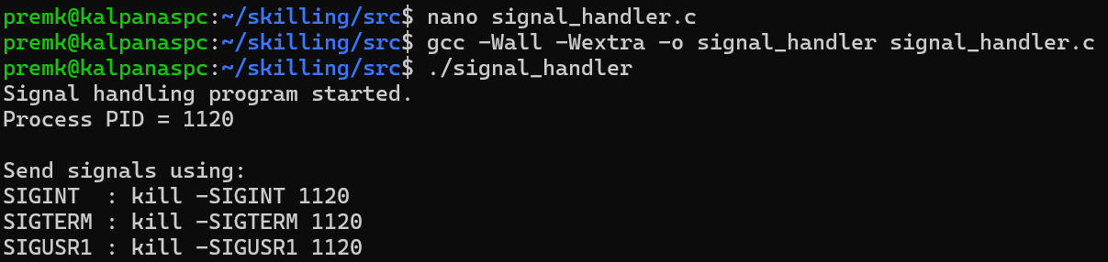
2nd terminal
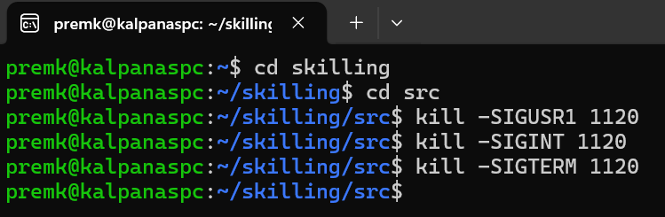
1st terminal
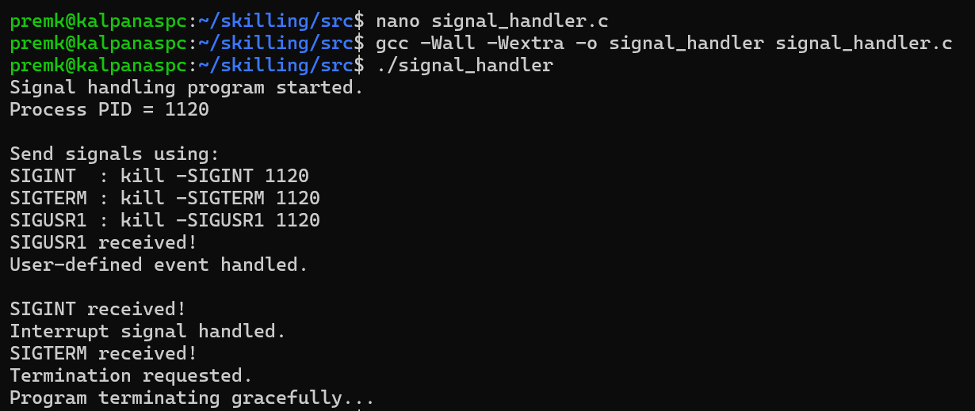
Important concept demonstrated
The program uses:
sigaction(SIGINT, &sa, NULL);
sigaction(SIGTERM, &sa, NULL);
sigaction(SIGUSR1, &sa, NULL);
The signal handler executes asynchronously when the corresponding signal is delivered. The handler only sets volatile sig_atomic_t flags; the main program performs the actual processing afterward. This is safer than doing complex operations such as printf() directly inside a signal handler.

